**LIT ASSIGNMENT - DAY 14**

Batch: SAP ABAP ON HANA Date:19th Oct 2022

EMP ID:46255236

CDS-Assignment 1 – Create a Simple CDS view with Date Functions in ABAP CDS Views

**Tables involved** – VBAK

@AbapCatalog.sqlViewName: 'Z36_SQL_VIEW'

@AbapCatalog.compiler.compareFilter: true

@AbapCatalog.preserveKey: true

@AccessControl.authorizationCheck: #NOT_REQUIRED

@EndUserText.label: 'CDS VIEW WITH DATE FUNCTIONS'

**define** **view** Z5236_CDS_VIEW **as** **select** **from** vbak **{**

vbeln **as** Sales_Document**,**

auart **as** Sales_Document_Type**,**

audat **as** Document_Date**,**

vdatu **as** Requested_delivery_date**,**

DATS_DAYS_BETWEEN**(**audat**,** vdatu**)** **as** no_of_days**,**

DATS_ADD_DAYS**(**vdatu**,** 10**,** 'NULL'**)** **as** shipping_date**,**

DATS_ADD_MONTHS**(**vdatu**,** 2**,** 'NULL'**)** **as** billing_date

**}**

**OUTPUT:**

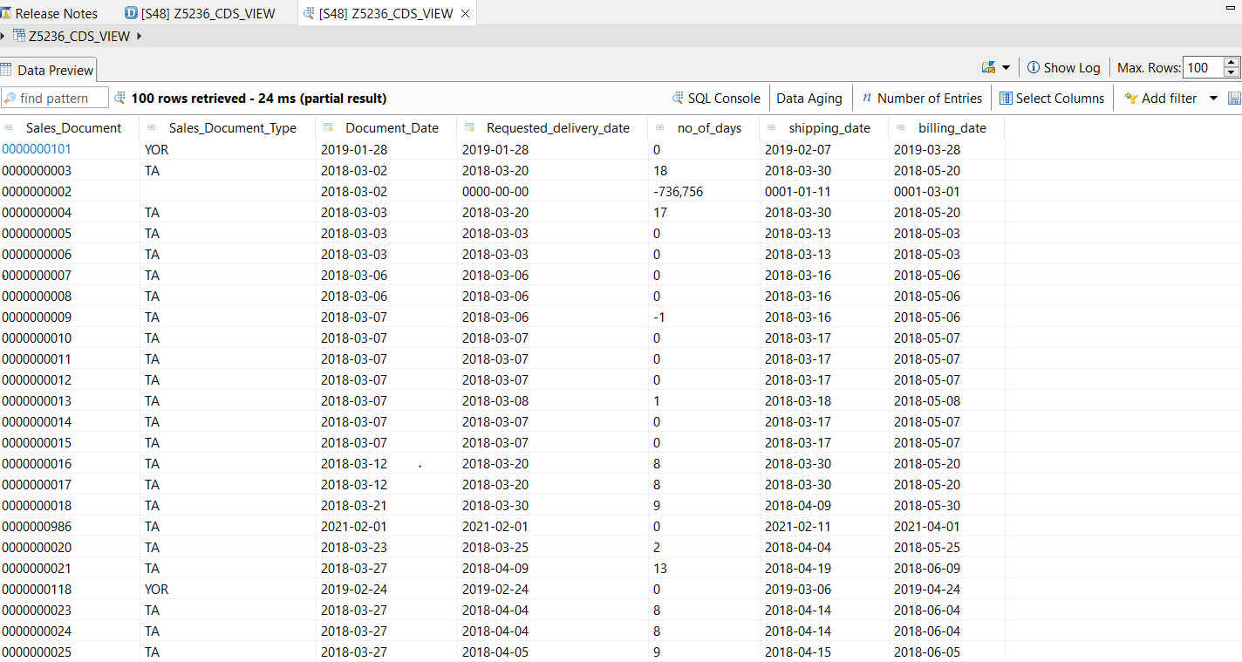

CDS-Assignment 2 – Create a Simple CDS view with String Functions in ABAP CDS Views

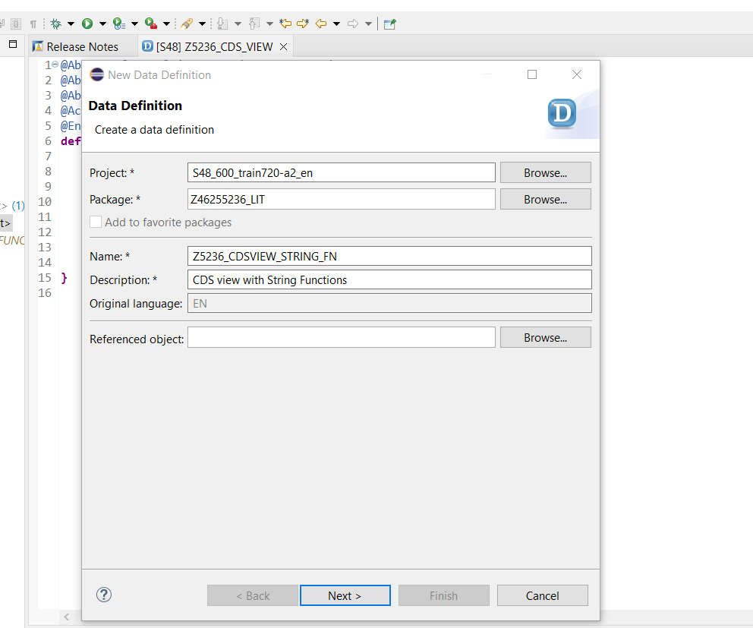

@AbapCatalog.sqlViewName: 'Z36_STR_FN_VIEW'

@AbapCatalog.compiler.compareFilter: true

@AbapCatalog.preserveKey: true

@AccessControl.authorizationCheck: #NOT_REQUIRED

@EndUserText.label: 'CDS view with String Functions'

**define** **view** Z5236_CDSVIEW_STRING_FN **as** **select** **from** kna1 **{**

kunnr **as** Customer_Number**,**

land1 **as** Country_Key**,**

concat**(**kna1**.**name1 **,** kna1**.**name2**)** **as** concat_fields**,**

concat_with_space**(**stras**,**ort01**,**2**)** **as** con_space **,**

left**(**name1**,**2**)** **as** no_of_char_left**,**

right**(**kna1**.**name1**,**3**)** **as** no_of_char_right**,**

length**(**telf1**)** **as** no_of_char**,**

substring**(**name1**,**2**,**4**)** **as** char_str**,**

ltrim**(**kunnr**,** '0'**)** **as** rem_zeros**,**

rtrim**(**telf1**,**'4'**)** **as** rem_last_char

**}**

OUTPUT:

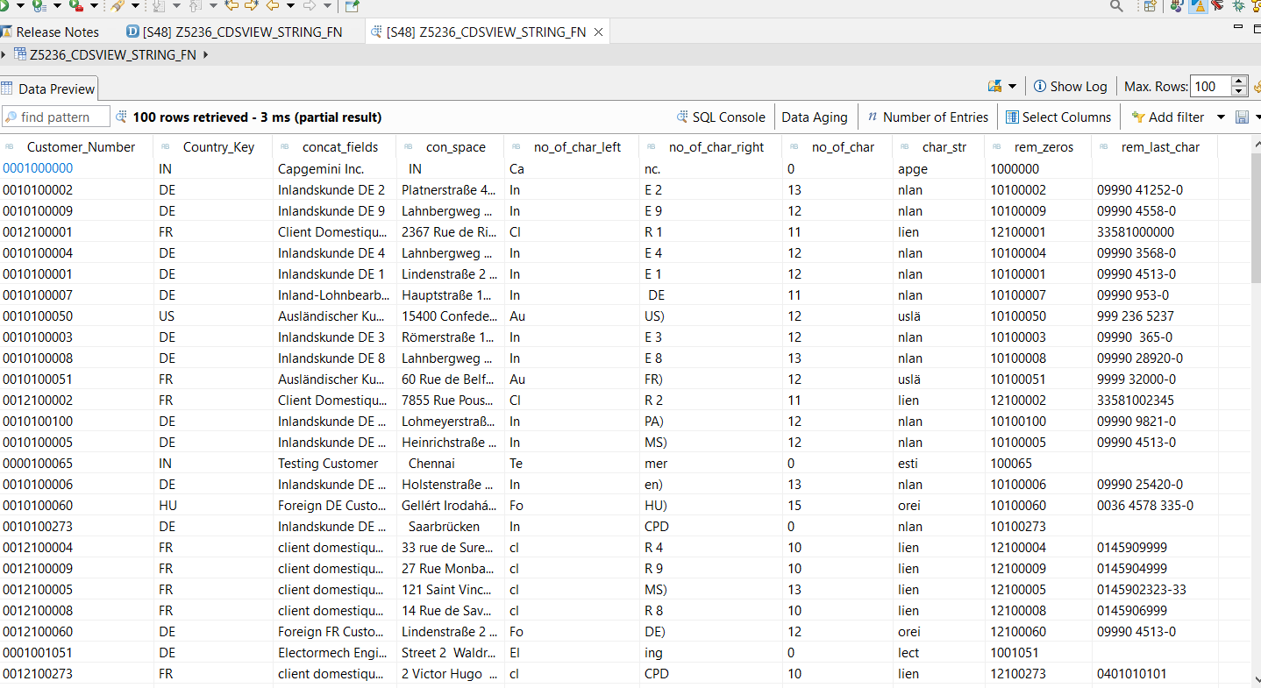

CDS-Assignment 3 – Create a Simple CDS view with Parameters

**Scenario** –

* Create a CDS view with GL currency (PSWSL) as parameter and get the entries form BSEG

**Tables involved** – BSEG

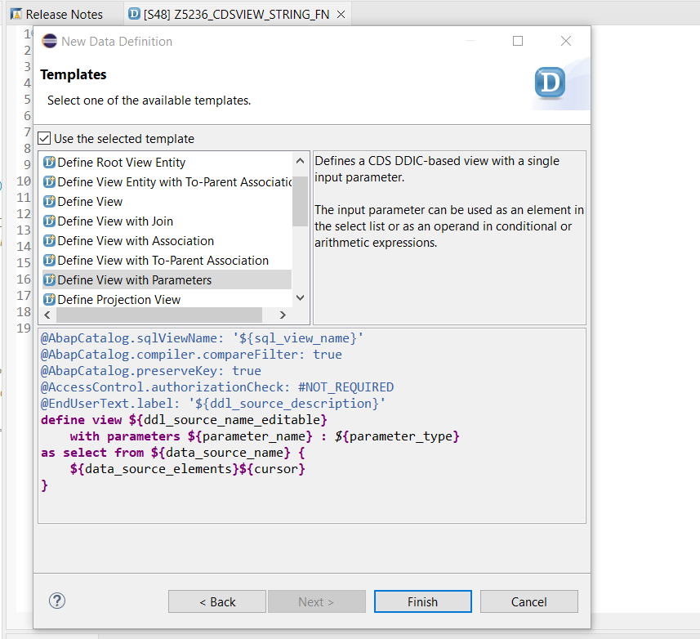

@AbapCatalog.sqlViewName: 'Z36_SQL_VIEW1'

@AbapCatalog.compiler.compareFilter: true

@AbapCatalog.preserveKey: true

@AccessControl.authorizationCheck: #NOT_REQUIRED

@EndUserText.label: 'CDS view with Parameters'

**define** **view** Z5236_CDSVIEW_PARA

**with** **parameters** in_curr **:** *abap***.***cuky***(**5**)**

**as** **select** **from** bseg**{**

bukrs**,**

belnr**,**

gjahr**,**

buzei**,**

augdt**,**

pswsl

**}where** pswsl **=** **$parameters.**in_curr

**output:**

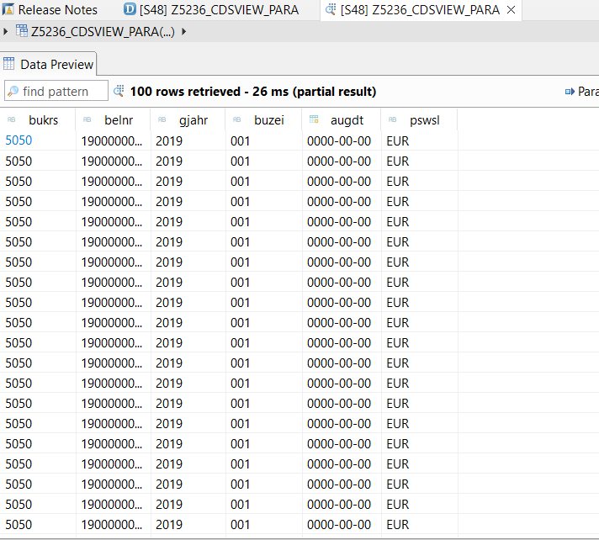

AMDP-Assignment 1 – Procedures - create a basic procedure to fetch data with scalar variable

**Scenario** –

* Print Sales Order number, Material Number, Quantity from VBAP table using scaler variable

**Tables involved** – VBAP

CLASS z5236_amdp_scal DEFINITION

PUBLIC

FINAL

CREATE PUBLIC .

PUBLIC SECTION.

INTERFACES :IF_AMDP_MARKER_HDB.

METHODS: get_vbap_data

EXPORTING VALUE(lt_VBAP) TYPE Z5236TTSTU_VBAP.

PROTECTED SECTION.

PRIVATE SECTION.

ENDCLASS.

CLASS z5236_amdp_scal IMPLEMENTATION.

METHOD get_vbap_data BY DATABASE PROCEDURE FOR HDB LANGUAGE

SQLSCRIPT OPTIONS READ-ONLY

USING VBAP.

lt_vbap = select vbeln,matnr,ZMENG from vbap;

endmethod.

ENDCLASS.

**REPORT:**

REPORT z5236_amdp.

z5236_amdp_scal=>get_vbap_data( IMPORTING lt_vbap = DATA(ex_data) ).

TRY.

CALL METHOD cl_salv_table=>factory

IMPORTING

r_salv_table = DATA(lr_salv)

changing

t_table = ex_data.

CATCH cx_salv_msg.

ENDTRY.

lr_salv->display( ).

**OUTPUT:**

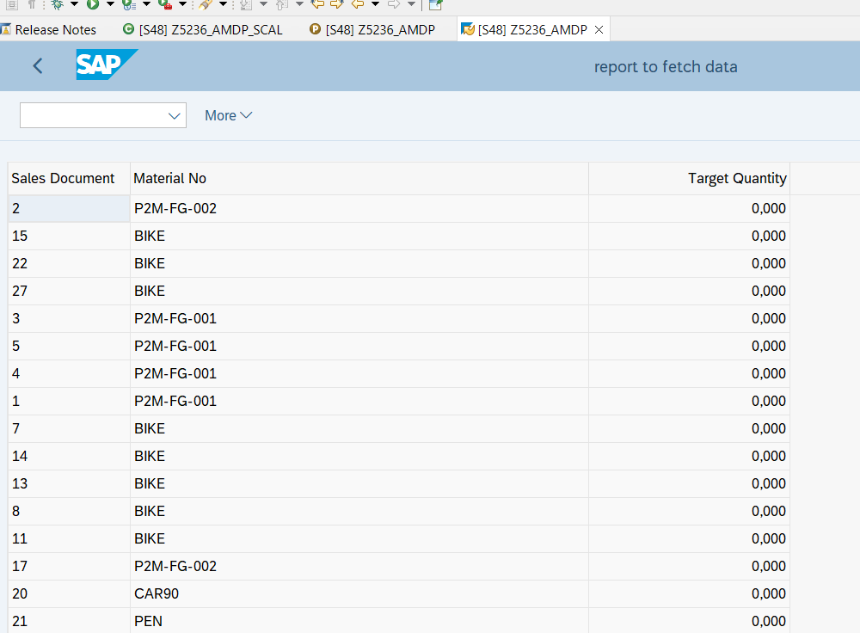

AMDP-Assignment 2 – Procedures - create a basic procedure with Table

**Scenario** –

* Select VBELN, VKORG, MATNR, MENGE from VBAK and VBAP and display the data using table based on material (MATNR).
* MATNR will be input field
* Do inner join

**Tables involved** – VBAK, VBAP

CLASS z5236_amdp_join DEFINITION

PUBLIC

FINAL

CREATE PUBLIC .

PUBLIC SECTION.

INTERFACES : IF_AMDP_MARKER_HDB.

CLASS-METHODS:GET_DATA

IMPORTING VALUE(IM_MATNR) TYPE VBAP-MATNR

EXPORTING VALUE(ET_RES) TYPE Z5236TTSRU_IN.

PROTECTED SECTION.

PRIVATE SECTION.

ENDCLASS.

CLASS z5236_amdp_join IMPLEMENTATION.

METHOD get_data BY DATABASE PROCEDURE FOR HDB LANGUAGE

SQLSCRIPT OPTIONS READ-ONLY

USING VBAP VBAK.

ET_RES = SELECT A.VBELN,

A.VKORG,

B.MATNR,

B.ZMENG

FROM VBAK AS A

INNER JOIN VBAP AS B

ON A.VBELN = B.VBELN;

ENDMETHOD.

ENDCLASS.

REPORT:

REPORT z5236_amdp_join.

PARAMETERS: S_MATNR TYPE VBAP-MATNR.

z5236_amdp_join=>get_data( EXPORTING IM_MATNR = S_MATNR

IMPORTING ET_RES = DATA(EX_RES) ).

TRY.

CALL METHOD cl_salv_table=>factory

IMPORTING

r_salv_table = DATA(lr_salv)

changing

t_table = ex_res.

CATCH cx_salv_msg.

ENDTRY.

lr_salv->display( ).

OUTPUT:

